**Lab :02**

**EXERSICE:**

**Exercise 01:**

Calculate Standard Deviation and Variance using python functions.

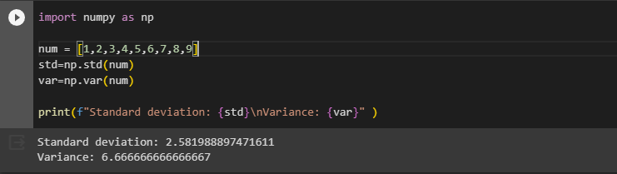

**Exercise 02:**

Take input string name from the user and display the names having more than 5 letters.

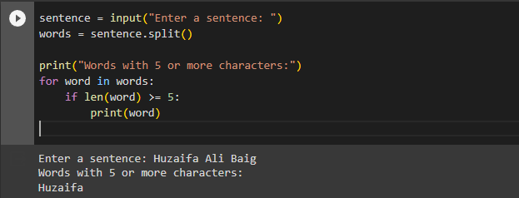

**Exercise 03:**

Write a Python function that checks whether a passed string is palindrome or not.

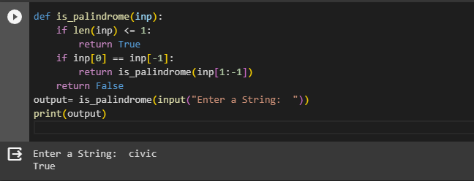

**Exercise 04:**

You input a number and the function created checks whether the number belongs to the Fibonacci sequence or not. The underlying workings are similar to the above ‘Leap it!’ program.

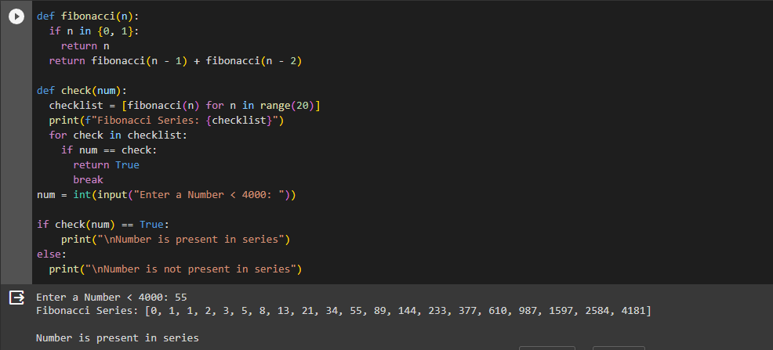

**Exercise 05:**

Write a Python program to check whether the given integer is a multiple of 5 and 7 both using function.

